**READING**

**1 - Which of the skills in the box are important for these jobs? Choose the two most important skills for each job.**

**analytical - communication skills - hard-working - IT skills –**

**language skills - motivated - organised - team worker**

**•** Digital Designer: _____________________________________________________

**•** Translator: _____________________________________________________

**•** Project Manager: _____________________________________________________

**•** Sales Assistant: _____________________________________________________

**•** Finance Officer: _____________________________________________________

**•** Small Business Owner: _____________________________________________________

**2 - Read the three job advertisements (A–C). Match them to three jobs in Exercise 1.**

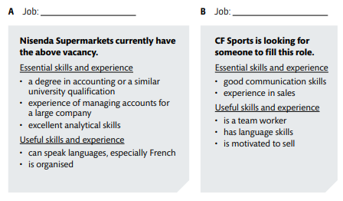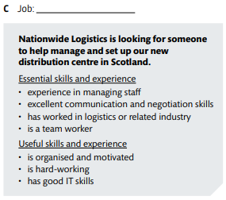

**3 - Reread the ads and answer the following question:**

* **What is a common requirement for the 3 (three) jobs?**

**________________________________________________________________________________________________________________________________________________________________**

**4 - Complete with Nisenda Supermarkets (NS), CF Sports (CFS) or NL (Nationwide Logistics). In some cases, more than one answer may be possible.**

1. **_________** requires a university degree.
2. **_________** requires team working skills.
3. **_________** requires organizational skills.
4. **_________** considers IT skills are important.
5. **_________** requires motivation.
6. _________ requires communication skills.
7. _________ requires to be a hard-working employee.

**USE OF ENGLISH**

**The best person for the job**

**5 - Complete the questions with the words in the box.**

**candidates – choose – degree – languages – qualifications – essential – vacancies**

1. What are the best __________________for the job?
2. Who will we __________________ for the job?
3. Which __________________ have worked in other countries?
4. What type of university __________________ do you need for this job?
5. How many __________________ are there in your department?
6. Which __________________ are useful for this job?
7. Is it __________________ to have previous work experience? Yes, it´s necessary.

**PRESENT PERFECT**

**6 Choose the correct option, a or b.**

1 I have ______ travelled to the company’s headquarters in Munich. Have you?

a) ever b) never

2 Has she ______ in the tourism industry?

a) been b) went

3 She ______ on some international projects. She went to Japan and India last year.

a) hasn´t worked b) has worked

4 ______ much experience with meetings in English?

a) Have you had b) Haven’t you have

5 Which companies has she ______ for?

a) works b) worked

6 Patrick and I haven’t ______ to the client recently.

a) spoken b) spoke

7 Has he ______ presentations in English?

a) gave b) given

8 ______ used this software program?

a) They have never b) Have they ever

9 He ______ studied abroad.

a) hasn’t b) haven’t

10 Tom and Lisa have ______ many sales reports.

a) written b) write

**7 - Complete the sentences with the correct verb form for talking about experiences**

1. Fumiko _________________ (never use) this software program.
2. Nadia and Kim _________________ (not work) together before.
3. Will _________________ (study) in the USA.
4. Ulla _________________ (write) three reports this month.
5. I _________________ (manage) my own company for many years.
6. Marcos _________________ (not travel) for work this year.

**8 – Choose the correct answer.**

1. Eugenio **gave / has given** many presentations of different products. He **gave / has given** the last one on Thursday.
2. Katie **has never had / never had** a job interview. This is her first one.
3. **I've been / I went** to Australia on business last summer. It was amazing.
4. Charlie and I **worked / have worked** on many projects. The most difficult **was / has been** the printing project in February last year.
5. Kamal **has visited / visited** many factories in Africa but he hasn't been to any in Asia.
6. **We opened / We've opened** a new restaurant last year. Not many people came up first.

**WRITING**

**9 – Imagine you are Anna Thompson. Use the information below and write a professional profile.**



